MRI TALAIRACH ALIGNMENT TOOL

# Purpose

This tool is used to transform freesurfer 3D models together with registered electrode locations into normalized talairach space. This procedure enables comparison of electrode locations between subjects.

# How to

To project a given 3D model and the register into Talairach space, we need:

* The freesurfer segmentation
* The electrode locations
* The talaraich space alignment points

If the freesurfer segmentation is not available, the tool will need at least:

* Matlab model .mat file  
  (contains the following structures: cortex, cmapstruct, ix, tala, vcontribs, viewstruct)
* Talaraich space alignment points
* The xfrm_matrices or the .mgz file which was used to extract the alignment points

## Find Talairach Space Alignment Points

To transform a 3D model into the talairach coordinate system we need 3 points. The talairach coordinate system required the following three points for a transformation:

1. AC (anterior commissure)
2. PC (posterior commissure)
3. mid-sag (mid-saggital inter-hemispheric point)

A general guide to the localization can be found here:

<https://mipav.cit.nih.gov/documentation/presentations/talairach.pdf>

### Step by Step procedure

1. Open the corresponding MRI for the subject. This file is typically within the freesurfer directory: <freesurfer path>/subjects/<MRIsubject>/mri/orig.mgz.   
   If you did not start the freesurfer segmentation, but imported the subject using freesurfers “recon-all -s “ you will not have this file. In this case you can use the MRI located in: <freesurfer path>/subjects/<MRIsubject>/mri/orig/001.mgz
2. Localize point AC according to the general guide above.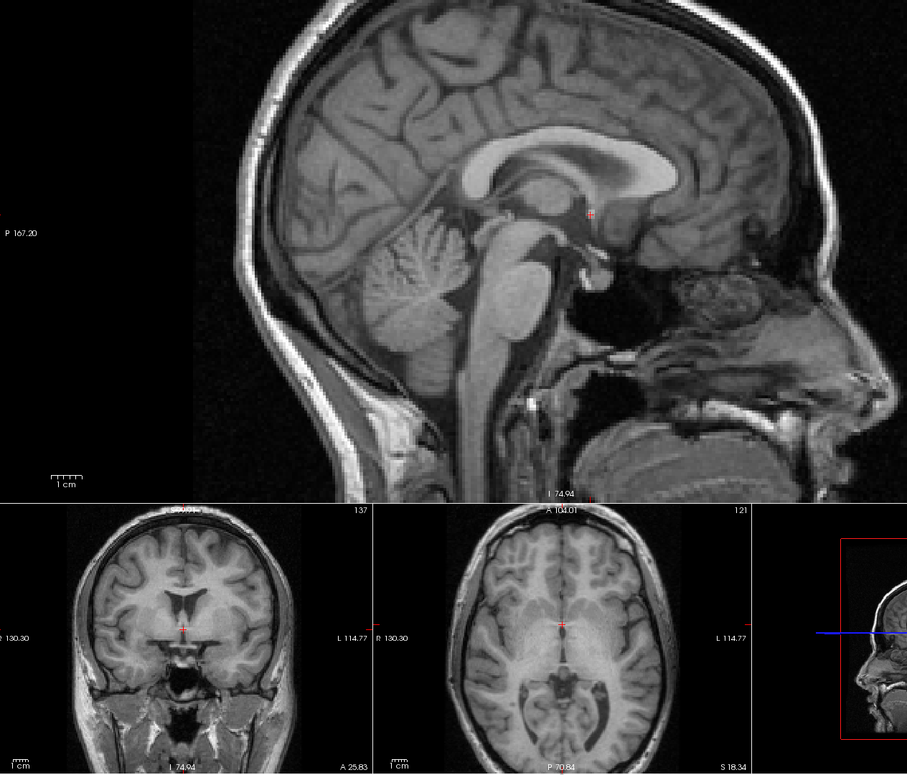  
   Add a new Point with the name **AC** in the Point Sets tab. Click on the Point you marked previously with the cursor. You can deactivate the option “Snap to voxel center” for a smoother point positioning.
3. Localize point PC  
   Make sure you have left Point Set Mode. To switch back to navigation mode click on Action->Navigate.   
   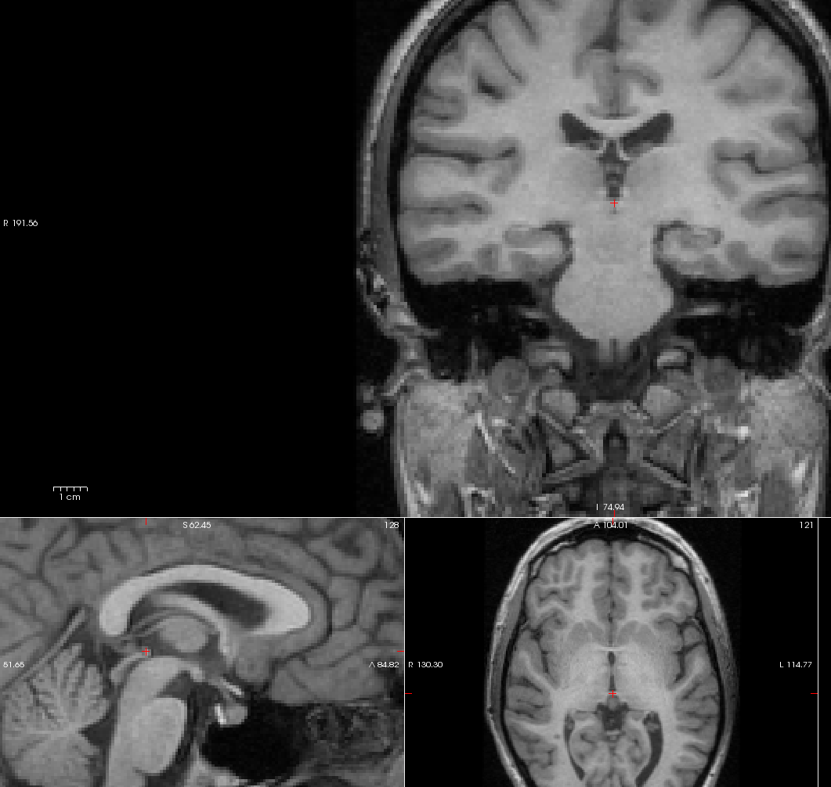  
   Create a new Point called **PC** and click on the marker so that another green marker appears for this point.
4. Repeat the procedure for the mid-sag point. The mid-sag point should be located in the hemispheric space and should be positioned somewhere between AC and PC on the sagittal pane.

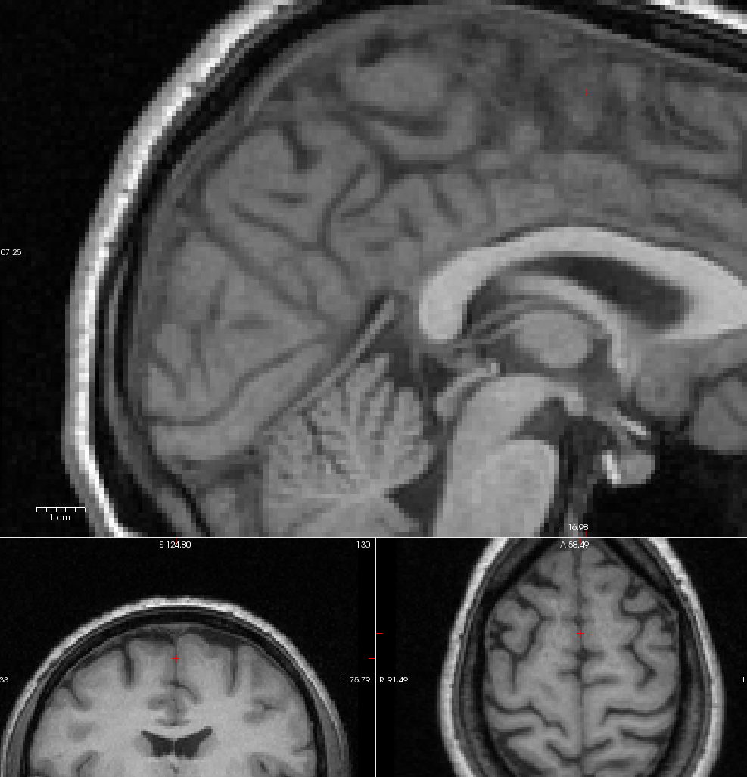

Create a new point called **mid-sag**

1. Store each point in the same folder. You should end up with three files called AC.dat, PC.dat and mid-sag.dat  
   Be careful, freeview always resets the path when you save data points! Make sure that you have write permission to the folder you are using to store the point, otherwise freeview might crash!

## Start MRI_ALIGNMENT_TOOL

The MRI_ALIGNMENT_TOOL matlab code should consist of the following root directory files:

* A directory called activeBrain (contains plotting functions)
* A directory called alignmentTool (contains the alignment algorithm)
* A directory called alignmentTool (standard talairach brain)
* get_xfrm_matrices.sh ! Make sure that this file has execution permission (chmod +x )!
* RunMeAlignSubject.m (Run script for alignment)

### Step by Step procedure

1. Check if the freesurfer path in the RunMeAlignmentSubject.m is correct (this is the folder which contains the freesurfer folder)
2. Run the Alignment Script
3. Select an Output Directory (This directory will contain the results and all intermediate steps)
4. If you want to create the aligned 3D model directly from the freesurfer output use “Load from Freesurfer”.  
   If you want to use a finished Matlab model (.mat) use “Load from mat”. If you load choose to use the Matlab model, you will not need the freesurfer segmentation, but you will still need either the xfrm_matrices or the original .mgz MRI which was used to create the 3D model.
5. Follow the instructions of the prompts.
6. Inspect the result to make sure that the output is correct.   
   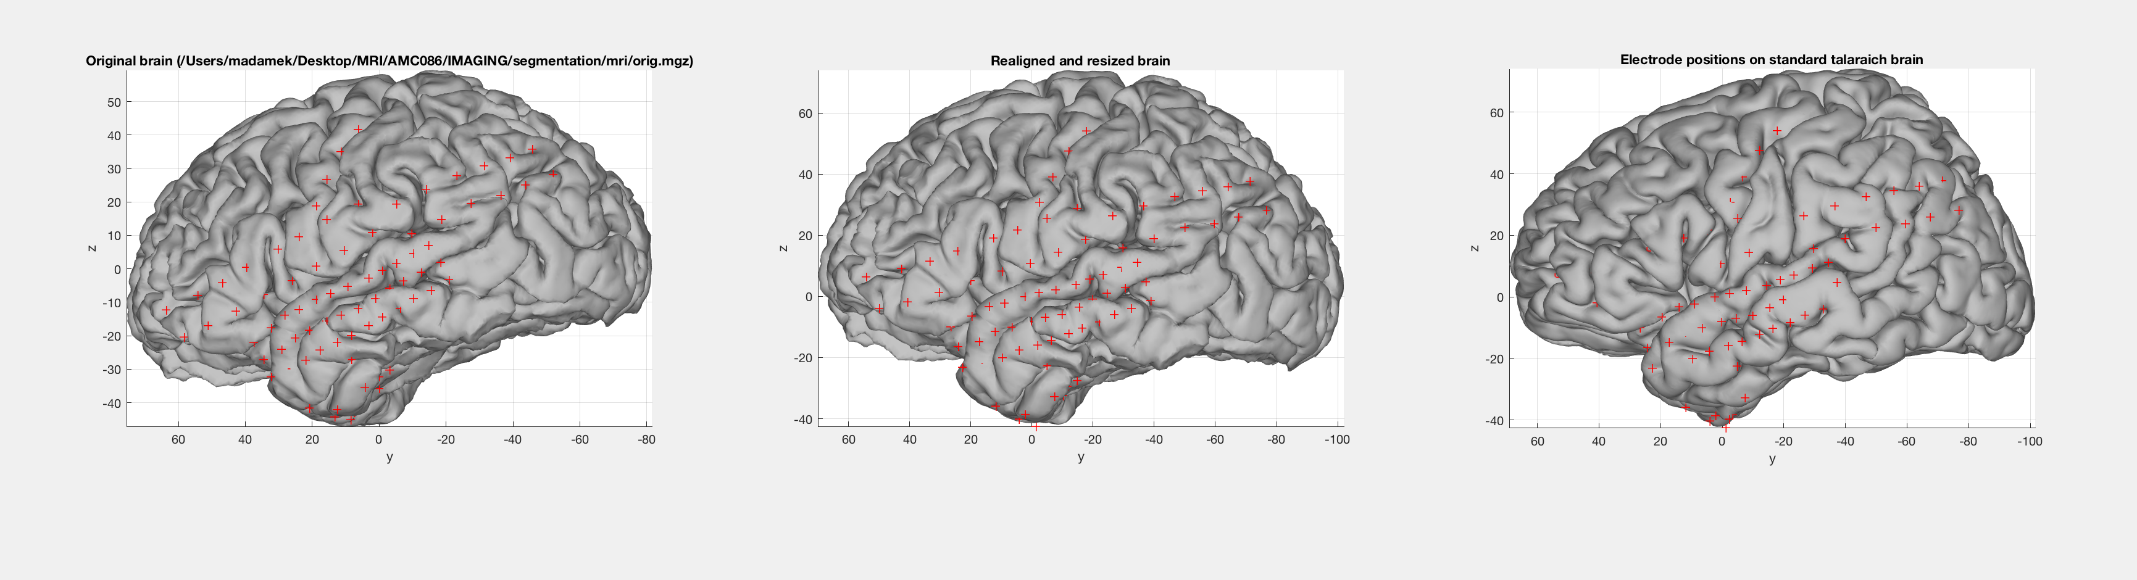
7. If you want to rerun parts of the realignment delete the corresponding intermediate result file.  
   The Result folder will contain the following items:

* aligned_brain_model.mat   
  The original 3D brain, aligned in talairach coordinate space
* alignment_points.mat  
  The alignment points after projection with the xfrm matrices
* brain_model_raw.mat  
  The raw brain model created from the freesurfer segmentation (only available if you used the freesurfer segmentation output)
* electrode_locations.mat  
  electrode locations projected with the xfrm matrices (only available if you used the freesurfer segmentation output)
* orig_brain_model.mat  
  Either a copy of the Matlab brain model, or the equivalent created from the freesurfer segmentation
* talaraich_brain_model.mat  
  Talairach standard brain with the projected subjects electrodes.
* Xfrm_matrices  
  xfrm transformation matrix from the freesurfer MRI